Day 4

1. Making controller

* We make controller using this command



* They are located inside this

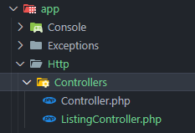

1. Controller in action

* First we made two functions in controller

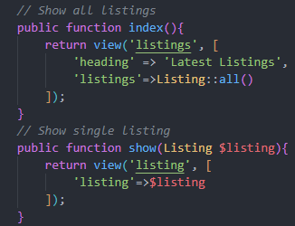

We just copy pasted the return from our route and passed arguments import in the single listing

* Now in route we changed the syntax such as



Don’t forget to import the controller

1. Some naming conventions:

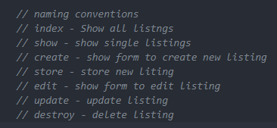

* So to use this we changed the listing and listings name

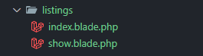

* Of course, the app breaks so just change this



1. Making the layout as a component

* First we moved the layout blade to the component folder
* Then we changed the code such as

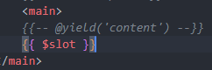

* Now all we need to do is wrap the listings with



1. Filtering the tags

* We can do either this



* Or



* We can see the tags using this



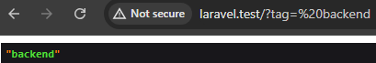

* Now to filter the process are as follows

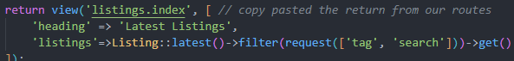

We passed in the tag and search as array because

* The scope filter takes in array

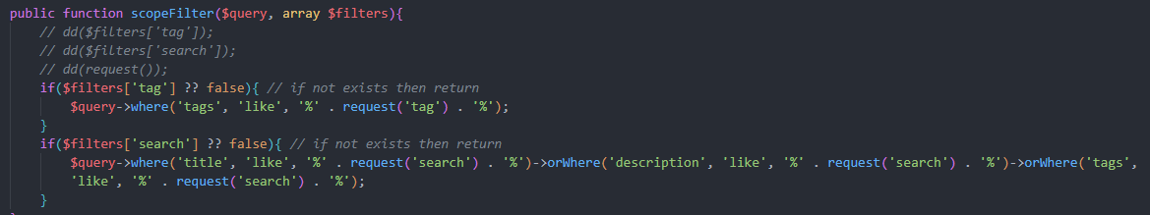

These code filtered everything out

1. Clockwork extension and package



* In chrome also add the extension
* Then whenever we use any method

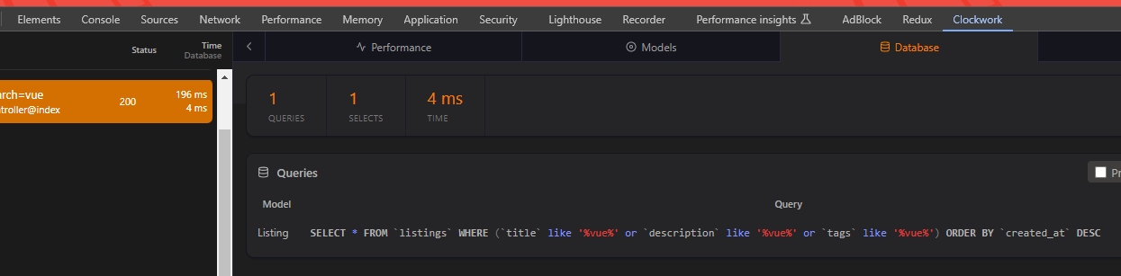

We get the SQL query

1. Creating create listing page

* We made view route but got one error

The 2nd one should be down because the first one won’t work because of same naming.

* 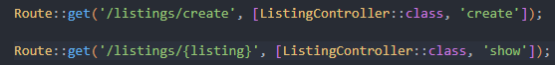
* We need csrf and specify post when doing post request



* Now we create new route and store controller
* We made this function with this DD

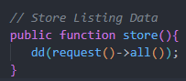

* Because of this after we submit the form we will see the values and is handy

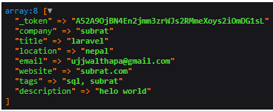

* VALIDATION

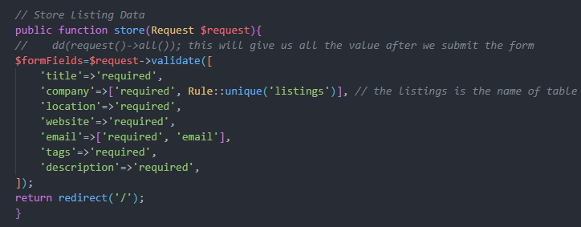

We created this validation code and

* With just adding the below code after every input tag

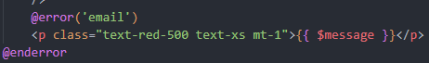

Changing the name of course

* We get this validation frrrr

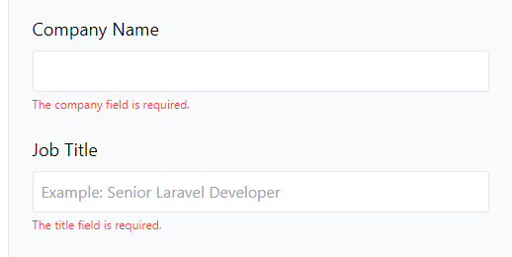

* Creating the value is piece of cake



* But this will cause error

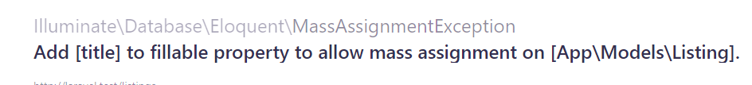

* So to fix this we do this in the model
* 
* And the error is gone and data is created